
Activity 2.3.8 Residential Water Supply

Introduction
Most people take it for granted that when they turn on a faucet, water is available. In fact a lot of planning has been completed to ensure that homes and business have adequate water. Engineers use codes and calculations to ensure that source and pressure are adequate. Historically civilizations in Rome and China were able to establish large urban areas and advance culture in large part because of their ability to transport large amounts of fresh water to citizens to meet their needs.

Equipment
- Calculator
- pencil
- Hazen Williams Constants & Equivalent Length of (Generic) Fittings handout

Procedure
Complete water supply calculations for each of the following.

- Complete the following calculations for your affordable home in your engineering notebook or journal.
Water Supply Line Facts
- The water line is 15 years old and is located 6 feet below 10th Street.
- The elevation at the lowest point of the tower’s water cavity is 872.81 ft.
- The pipe’s diameter is 8 in.
- The pipe’s length is 3.12 miles.
- The pipe is cast iron.
- The pipe has seven 90 degree flanged elbows and one 45 degree flanged elbow.
- The pipe’s flow rate is 100 gpm.
Satellite Image
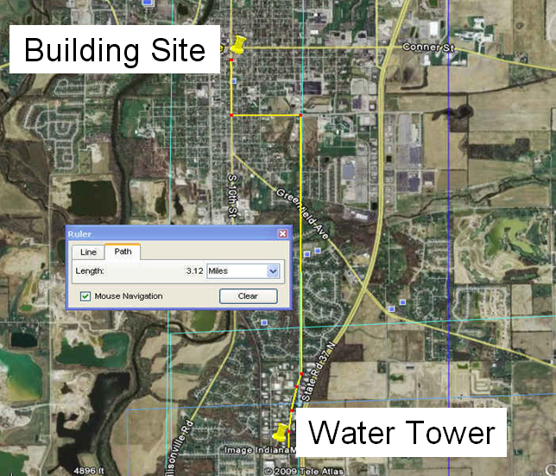
Site Plan
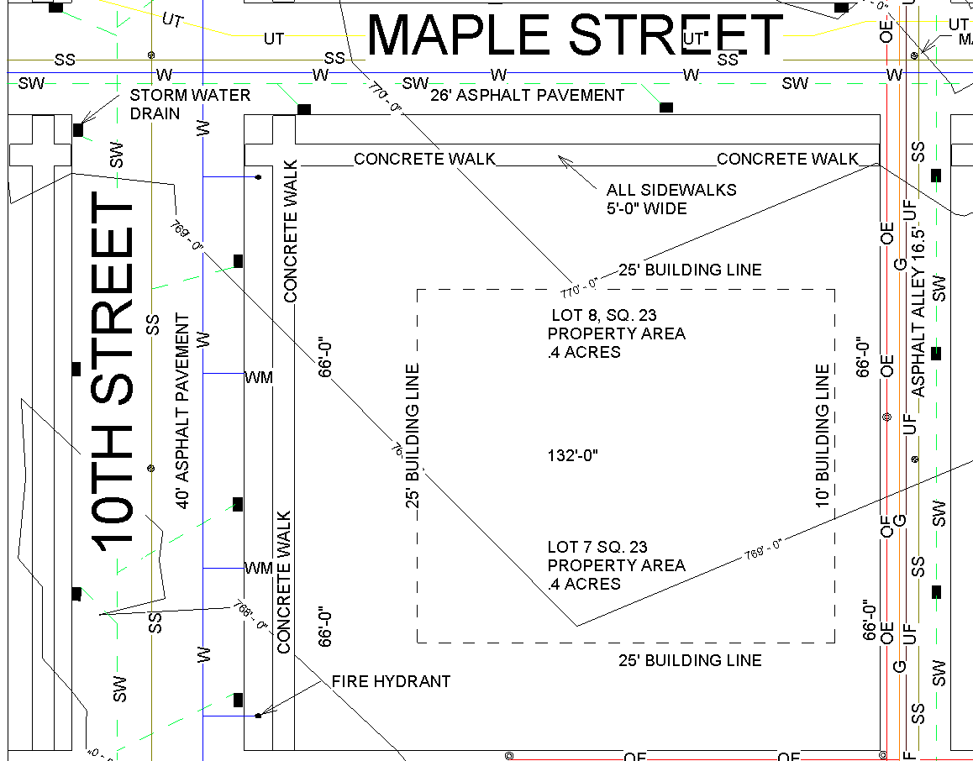

  - Calculate the static head at the point of discharge under 10th street excluding head loss.

  - Calculate the head loss, including the losses for pipe fittings.
  - Calculate the dynamic head at the point of discharge under 10th Street.

  - Calculate the actual pressure in front of the house.

  - Is the actual pressure sufficient for residential use? Should a pressure reducing valve be installed?
- A facility that receives water at an elevation of 350 ft at the water meter is 4.1 miles from the water tower. The water level in the tower is 527 ft. The water flow is rate is 110 gpm. Assume an 8 in. ductile or cast iron pipe with flanged fittings. The supply line includes the following fittings:
- 2-90 degree elbows
- 2 gate valves
- 17 line flow tees
- 6 branch flow tees
- 1 swing check valve

- Find the total dynamic head and actual water pressure at the water meter of this facility.

- What is the static head at a sink on the second floor if the sink faucet elevation is 14 feet above the meter elevation? Hint: static head depends only on elevation.

- The water supply line from the meter to the house and up to the second floor sink is a 1” copper pipe with screwed fittings. If the pipe from the meter to the second floor is a total of 75 feet long and includes four line flow tees, a swing check valve and seven regular 90- degree elbow, calculate the actual pressure at the sink. Assume a flow rate of 10 gpm. Hint: the actual pressure at the sink is affected by the head loss from the water tower to the sink (which included head loss from the tower to the meter and from the meter to the sink).

